

**UGANDA TEACHERS’ EDUCATION CONSULT (UTEC)**

**P.O. Box 1394, Kampala**

**Tel: 0772871370, 0704021725, 0701944097, 0772556532**

**Our Ref: UTEC/001/C/2024**

**Your Ref**:………………………

**Date**: 1st March, 2024

Dear Sir / Madam,

**RE: CIRCULAR TO HEAD TEACHERS OF SECONDARY SCHOOLS 2024 UCE AND UACE MOCK PROGRAMME.**

We thank all the schools that participated in the UTEC mocks 2023 for the support and feedback that has gone a long way in improving our performance.

Once again, the Consult will be conducting mocks and is requesting for your full participation.

The fees have remained as for last year: Ug. Shs. 30,000 (**THIRTY THOUSAND SHILLINGS ONLY) PER CANDIDATE PER LEVEL.**

The money / mock fee can be **deposited** by cheques or cash in the **Consult’s Bank Account No. 310001797** Centenary bank Ltd. The **account title** is: **Uganda Teachers’ Education Consult.**

The charges will cover all costs for setting, marking, processing results and generating reports for all subjects on our curriculum. There are no additional fees charged above what has been given. Any payments made shall be verified by our original receipts and stamp. The deadline for payment of examination fees is **5th July 2024**. This will enable the Consult to process examinations for each school on time. The Examinations are expected to begin on the **26th July 2024**, for ‘O’ **level** and **2nd August** for **‘A’ level.**

The results and subjects reports per school from the Consult’s Examination Secretariat will be ready by **14th September 2024**.

A soft copy of the candidates list for each level with names arranged alphabetically should be surrendered during registration at **PAL AND LISA SECONDARY SCHOOL KULAMBIRO – KISAASI.**

**NOTE:** TheConsult uses trained and reputable Examiners who conduct marking on residential basis under Conveyor Belt System (CBS). Coordinated Marking guides booklet shall be available at a fee of **Ug. Shs. 100,000** for **‘O’ level** and **Ug. Shs. 100,000** for ‘**A’ level** booklet.

All examination materials will be dispatched to schools after payments of full mock fees. Kindly comply to improve efficiency in results entry.

Attached is the road map to UTEC 2024.

**IMPORTANT DATES TO NOTE**

|  |  |
| --- | --- |
| **DATE** | **ACTIVITY** |
| 6th February 2024 | Beginning of setting exercise |
| 10th May 2024 | End of setting exercise |
| 27th May 2024 | Registration of schools for mocks starts |
| 5th July 2024 | Deadline for submission of applications to mark UTEC by new /additional examiners. |
| 16th July 2024 | Release of advance confidential instructions to Regional Coordinators |
| 26th July 2024 | Briefing of S.4 candidates |
| 26th July 2024 to 23rd August 2024 | Mock examinations in progress |
| 12th August 2024 | Dispatch of sms invitations to examiners |
| 24th August 2024 | Reporting of chief examiners to select dammies |
| 25th August 2024 | Reporting of examiners |
| 28th August 2024 | Checking starts |
| 14th September 2024 | Release of results for **UCE / UACE** and scripts |
| 28th September 2024 | **UTEC** general meeting |

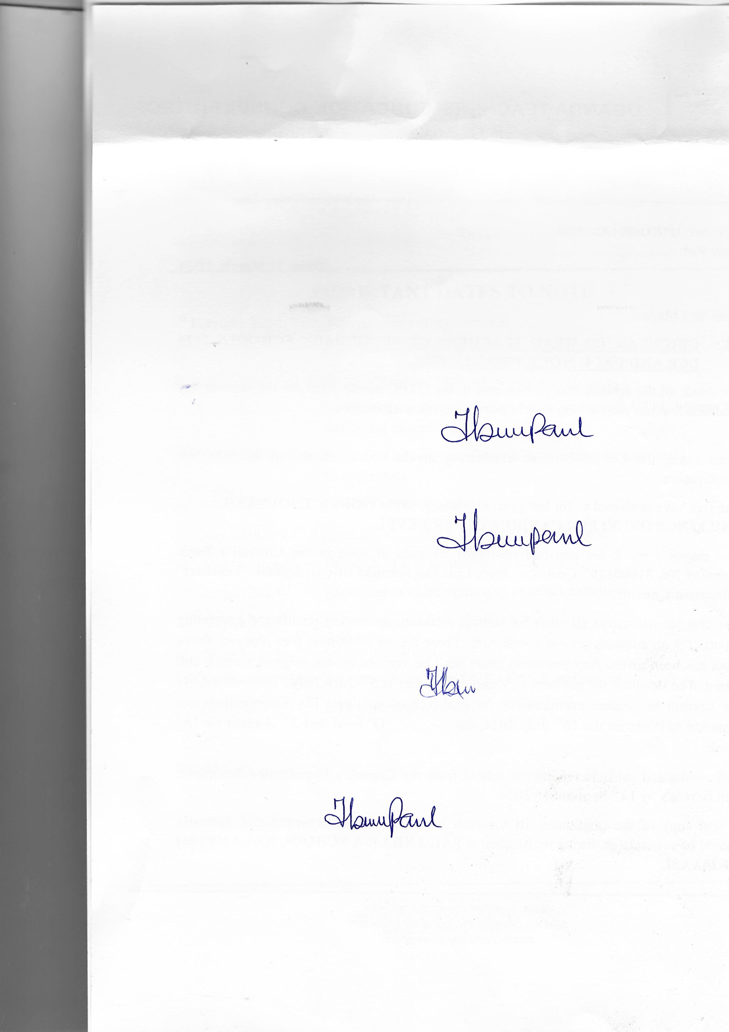Signed,

For Examination Committee

**UTEC**